**Linux Assessment-1**

1. **Which command is used to move a file from one directory to another?**

mv command.

Example: mv old location myfile.txt new location myfile.txt

1. **How do you change the permissions of a file to be readable, writable, and executable by the owner only?**

chmod command with symbolic mode: chmod u+rwx myfile.txt

u: This refers to the user, which is the owner of the file.

+: This means add permissions.

rwx: These are the specific permissions:

r: Read permission.

w: Write permission.

x: Execute permission.

So, u+rwx :"Add read, write, and execute permissions for the user of this file."

In other words, the owner of the file will have full access to read, modify, and execute the file.

1. **What command would you use to rename a directory called oldfolder to newfolder?**

mv command can also be used for renaming directories.

Example: mv oldfolder newfolder

1. **What is the command to display all active processes running on your system?**

ps aux

‘ps’ is the process status command.

‘a’ shows all processes, including those in the background.

‘U’ shows information about the user who owns the process.

‘x’ shows the full command line used to start the process.

1. **What is the command to check the available free memory on your system?**

free -m

free displays information about memory usage.

-m shows the output in megabytes.

1. **What command would you use to delete a directory named myfolder along with all its contents, including files and subdirectories?**

rm -rf myfolder

rm is the remove command.

-r recursively deletes subdirectories.

-f forces deletion without confirmation prompt

1. **What is the command to find the size of all files and directories, sorted in descending order?**

du -sh * | sort -nr

du -sh * estimates file and directory sizes in human-readable format (* represents all files).

sort -nr sorts the output numerically (by size) in reverse order (largest first).

1. **How would you recursively change the ownership of all files in a directory, but only for files and not for subdirectories?**

chown -R owner:group directoryname (replace owner and group with desired values)

chown changes file ownership.

-R applies recursively to subdirectories (files only in this case).

1. **Which command would you use to display disk space usage in human-readable format, but only for a specific directory and its subdirectories?**

du -sh (target directory)

du -sh displays size in human-readable format.

specifies the target directory.

1. **Use the ping command to check the connectivity to google.com. What result indicates that the server is reachable?**

ping google.com

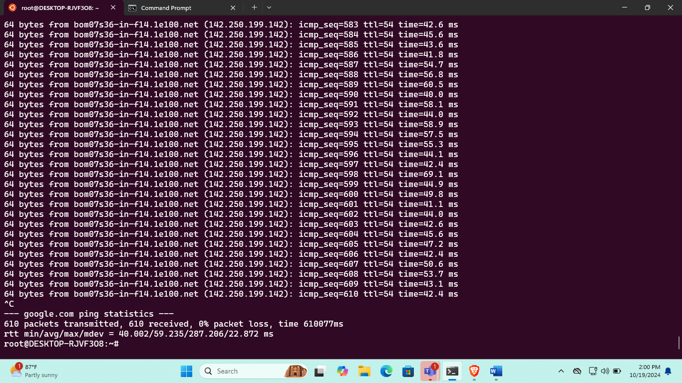

1. **How do you check the size of all files in a directory that are larger than 50MB?**

find pathtodirectory -size +50M -exec du -sh {} \;

find searches for files.

pathtodirectory specifies the target directory.

-size +50M filters for files larger than 50MB.

-exec du -sh {} \; executes du -sh (size in human-readable format) for each found file.

1. **What command would you use to find and delete files older than 1 day in a specific directory?**

find pathtodirectory -type f -mtime +1 -delete

find searches for files.

pathtodirectory specifies the target directory.

-type f filters for files only (not directories).

1. **What is the difference between df and du commands? When should you use each?**

**Difference between df and du commands:**

**df (Disk Free):**

Reports the amount of disk space available on a filesystem.

Shows information about mounted filesystems, their size, used space, available space, and inodes.

Used to check overall disk usage and available space on a system.

**du (Disk Usage):**

Reports the amount of disk space used by files and directories.

Provides a detailed breakdown of disk space usage within a directory hierarchy.

Used to identify specific files or directories that are consuming a large amount of disk space.

**When to use each:**

df: When you want a general overview of disk space usage across multiple filesystems.

du: When you need to pinpoint specific files or directories that are causing disk space issues.

1. **What is the difference between using symbolic mode (chmod u+x) and numeric mode (chmod 755) with the chmod command, and when would you prefer one over the other?**

**Difference between symbolic and numeric mode in chmod:**

**Symbolic mode:**

Uses human-readable symbols like u, g, o (user, group, other) and +, -, = (add, remove, set) to modify permissions.

Example: chmod u+x file.txt (adds execute permission for the user)

**Numeric mode:**

Uses a three-digit octal number to represent permissions for the user, group, and others.

Each digit represents permissions for read (4), write (2), and execute (1).

Example: chmod 755 file.txt (user: read, write, execute; group: read, execute; others: read, execute)

**When to use each:**

Symbolic mode: Generally preferred for most use cases due to its readability and ease of understanding.

Numeric mode: Useful when you need precise control over permissions and have a clear understanding of the octal representation.

1. **You want to make a script executable by the owner and readable by the group, but no permissions for others. Which chmod command would you use, and how do you interpret the permission settings?**

Making a script executable by the owner and readable by the group:

chmod u+x,g+r script.sh

u+x: Adds execute permission for the user.

g+r: Adds read permission for the group.

1. **How would you list the top 2 processes consuming the most memory on a Linux system?**

Listing the top 2 processes consuming the most memory:

top -n 2

top: Displays a list of processes.

-n 2: Shows only the top 2 processes.

1. **A user accidentally changes the permissions on an entire directory structure, making it inaccessible to the root user (chmod 000 /user/directory). How can you regain access to the directory and its contents?**

Regaining access to a directory with chmod 000:

1. Boot into single-user mode: This disables most services and grants root access without a password.
2. Remount the filesystem: Use mount -o remount,rw to remount the root filesystem as read-write.
3. Change permissions: Use chmod 755 userdirectory to restore permissions.
4. Reboot: Reboot the system to exit single-user mode.
5. **You are tasked with setting up a shared directory for a group of developers, but you need to ensure that any files they create in the directory are owned by the group, not the individual user. What combination of commands and configurations would you use to achieve this?**

Setting up a shared directory with group ownership:

* 1. Create the directory: mkdir -m 775 shared_directory
  2. Set group ownership: chgrp groupname shared_directory
  3. Configure file system permissions: Use umask 007 to set default permissions for newly created files to 770 (owner: read, write; group: read, write; others: none).

1. **A server is experiencing high load, and some processes seem to be consuming excessive memory. You’ve been tasked to identify the specific processes causing the issue and terminate them. How would you approach this task using available Linux commands?**

Identifying and terminating high-memory processes:

1. Use top: Monitor processes and look for those with high memory usage.
2. Identify PID: Note the Process ID (PID) of the offending processes.
3. Kill processes: Use kill -9 PID to forcefully terminate the processes.
4. **Explain how SSH (Secure Shell) works and describe the difference between password-based authentication and key-based authentication. Which method is more secure, and why? (Presentation for 1 to 2 mins).**

**SSH (Secure Shell)**

SSH provides a secure channel for remote access to a computer system. It uses encryption to protect data transmitted over the network.

**Password-based authentication**

Requires a username and password to establish a connection.

**Key-based authentication**

Uses public-private key pairs for more secure authentication. The private key is kept secret on the client machine, while the public key is distributed to the server.

**More secure**

Key-based authentication is generally considered more secure because it doesn't involve transmitting passwords over the network.

1. **How do you SSH into the remote machine? Describe the command you would use.**

ssh username@hostname

username: The username on the remote machine.

hostname: The IP address or hostname of the remote machine.